WEEK 3 REPORT
UWIMANA ANGELIQUE
ID:28868

CONTROL FLOW AND FUNCTIONS

PART1

Scenshot: exercise 1.1
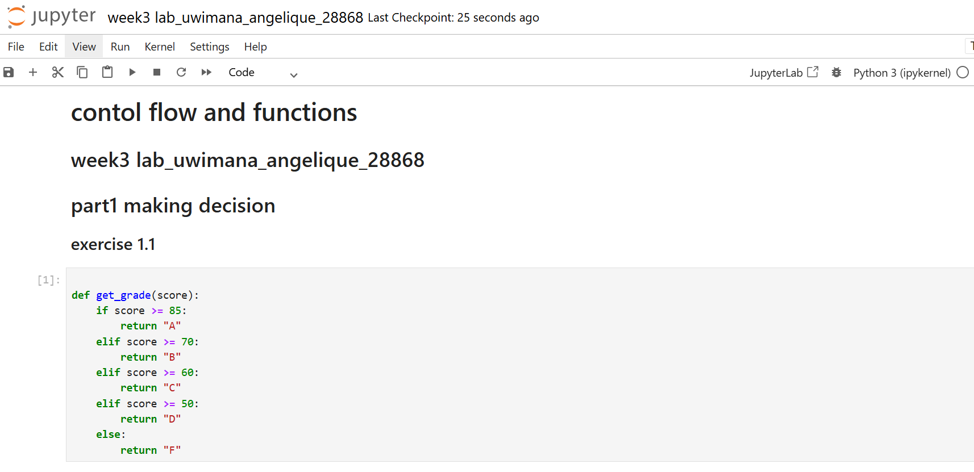
Sceenshot:exercise 1.2
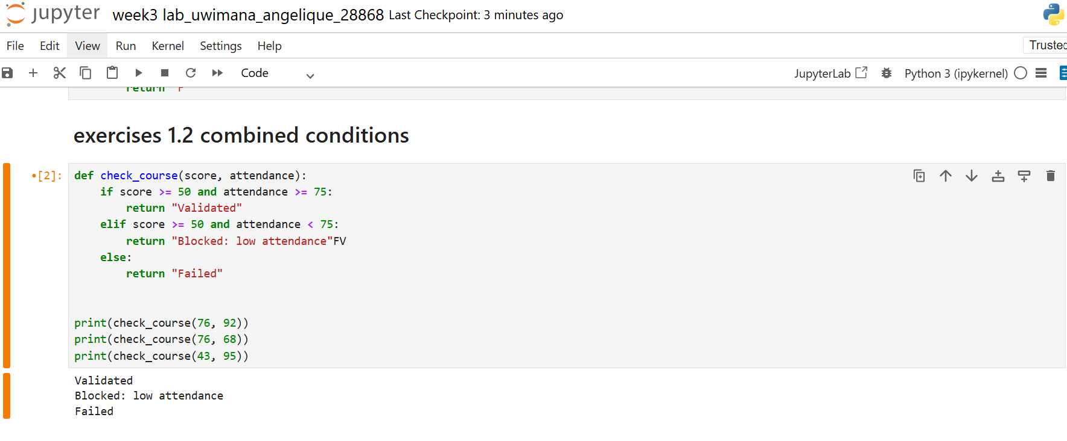
Screenshot: exercise 1.3
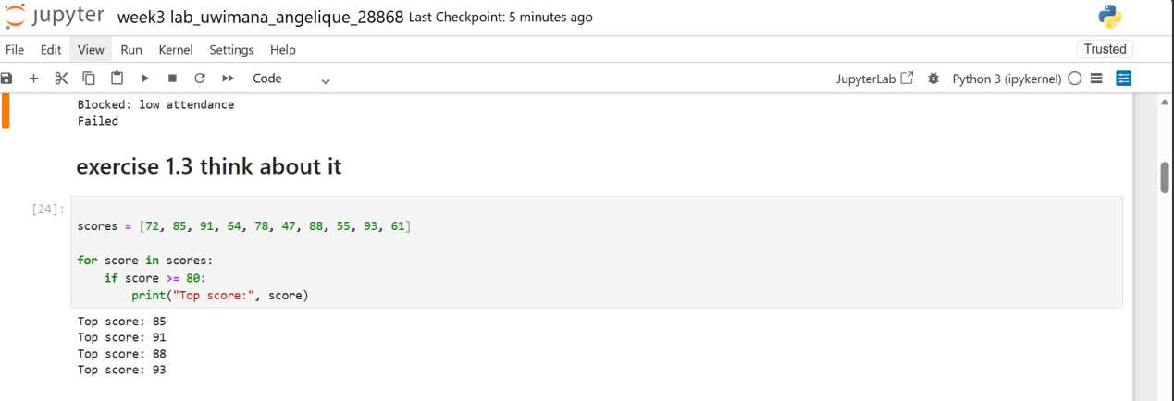
PART 2
Screenshot: exercise 2.1
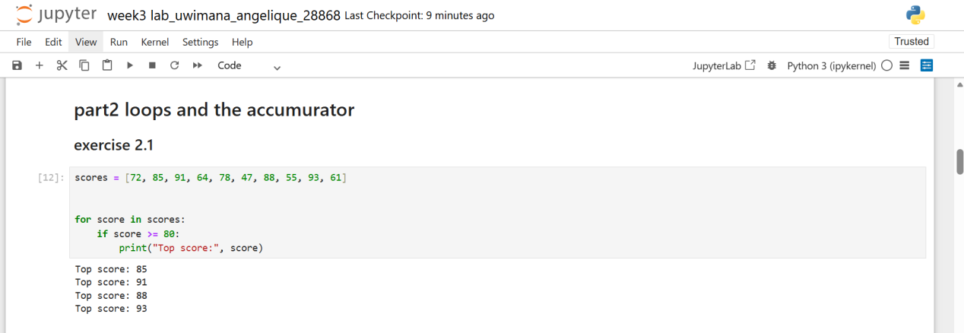
Screeenshot:exercise 2.2
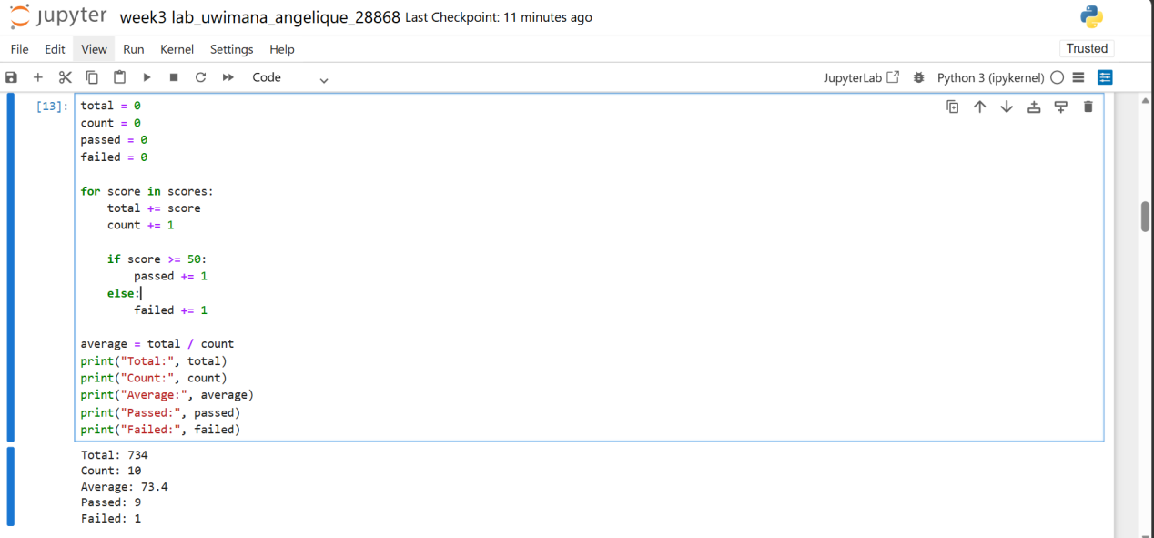
Screenshot:exercise 2.3
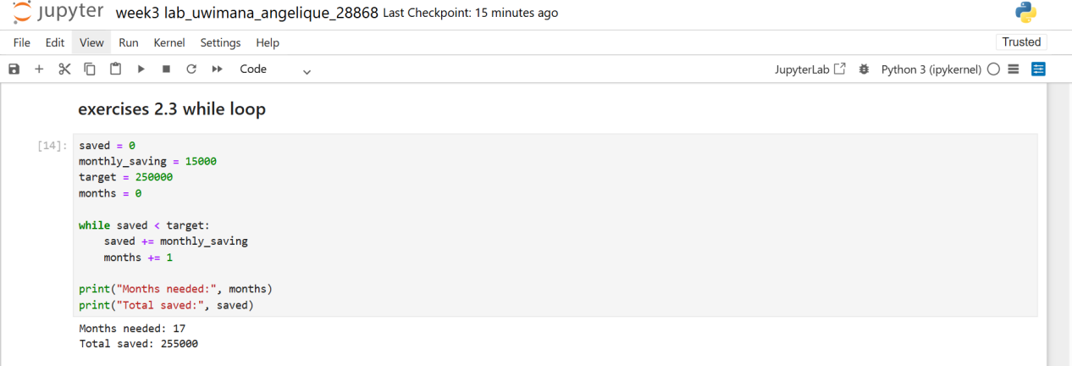
PART 3
Screenshot:exercise 3.1
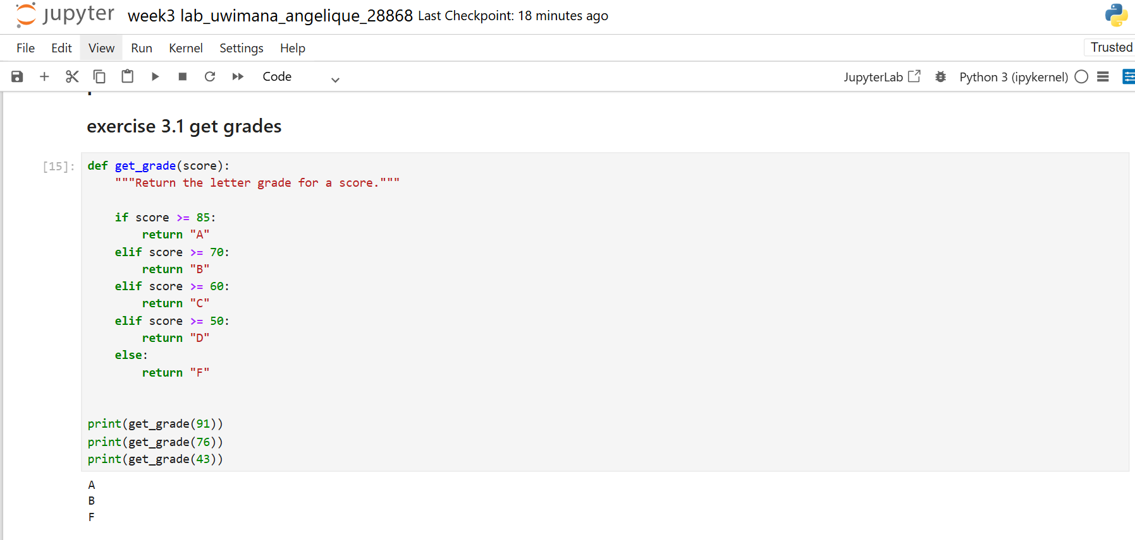
Screenshot:exercise3.2
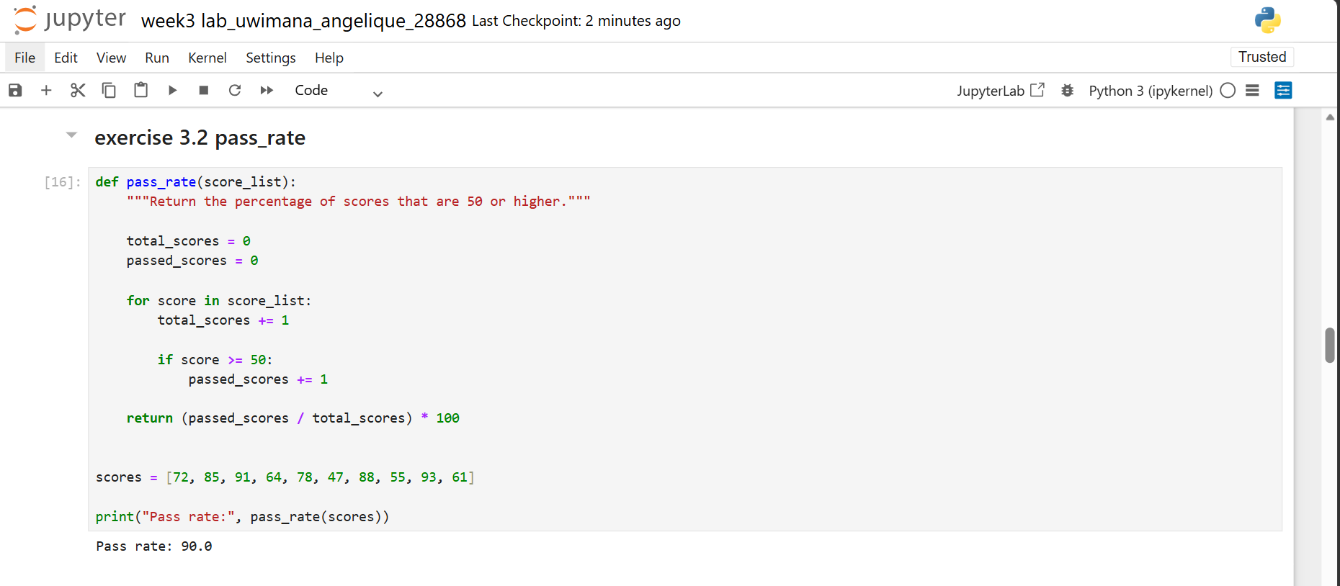PART 6: BONUS
